**Intelligent Traffic System**

**Stakeholder Problem Analysis:**

Making the route fast and obstacle free for ambulances and that too manually is not an easy task for the traffic police, as it causes a delay, and many patients lose their life because of not receiving the treatment in time. More than 20 percent of patients needing emergency treatment have died on their way to the hospital because of delays due to traffic jams. Traffic Management System is not flexible enough to give importance according to the priority of the work.

**Expectation:**

In Emergencies, the traffic signals should set the timer for a given route according so that ambulances reach the hospital in time. The manual work done by the Traffic Police Staff should be done by the Traffic Signal itself.

**Reality:**

In such emergencies, the traffic police have to come up and manually need to clear the traffic jam and make way for Ambulance, which indeed needs time.

**What’s needed:**

Traffic signals should automatically change their timers for different routes in emergencies. Traffic signals are fed with the timing statically, so they do not change in different situations, which causes traffic jams. So the Traffic Management System needs to upgrade itself, and it should receive input from the ambulances so that it clears the way for them without the interference of the manual work.

**Process Analysis:**

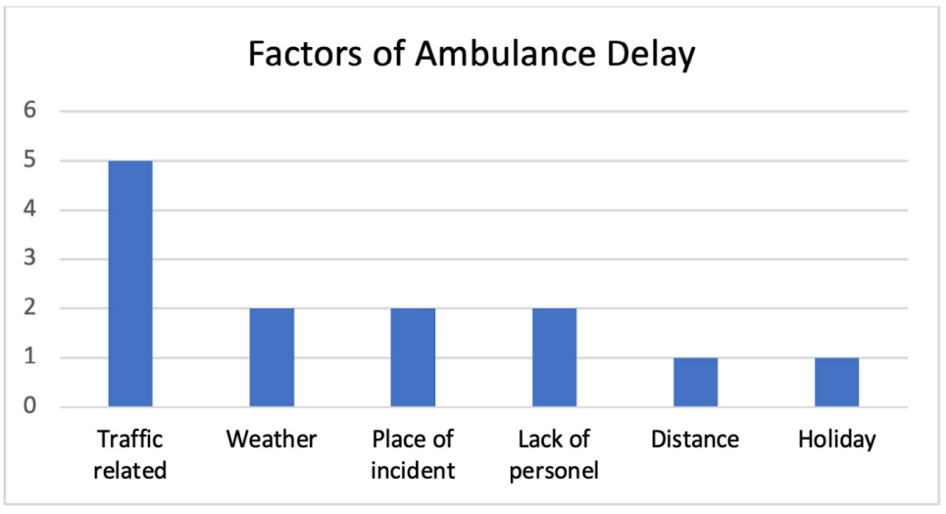

This review suggests that traffic conditions are the main factor causing ambulance delays. Traffic conditions cause a significant impact on ambulance delays. Therefore, there is a demand for a strategic solution to reduce the ambulance delay because of Traffic Jams.

**Reasons for facing a problem:**

Traffic signals are rigid so they can’t adapt to changing things. This causes delays to important work. The Police Staff needs time to manually make the way clear for an ambulance. Time taken to clear the traffic jams cost the patient to lose their life.

**Solution:**

* Live Tracking of the ambulance.
* Prioritize the route.
* Create an obstacle-free way for the ambulance.

**Solution Impact:**

* Effective management of Emergency Medical Services.
* Minimizes the number of fatalities.
* Ensures timely delivery of medical services.

**Process Design (Technical):**

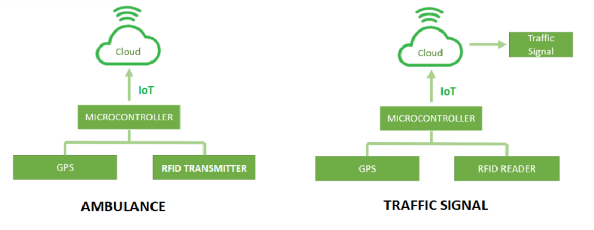

**Future:**

This will reduce the percentage of patients dying because of delays in reaching the hospital. The Intelligent Traffic Signal will open many other options for innovation and creativity. It also will give a financial boost to the IoT and Cloud Computing sectors.